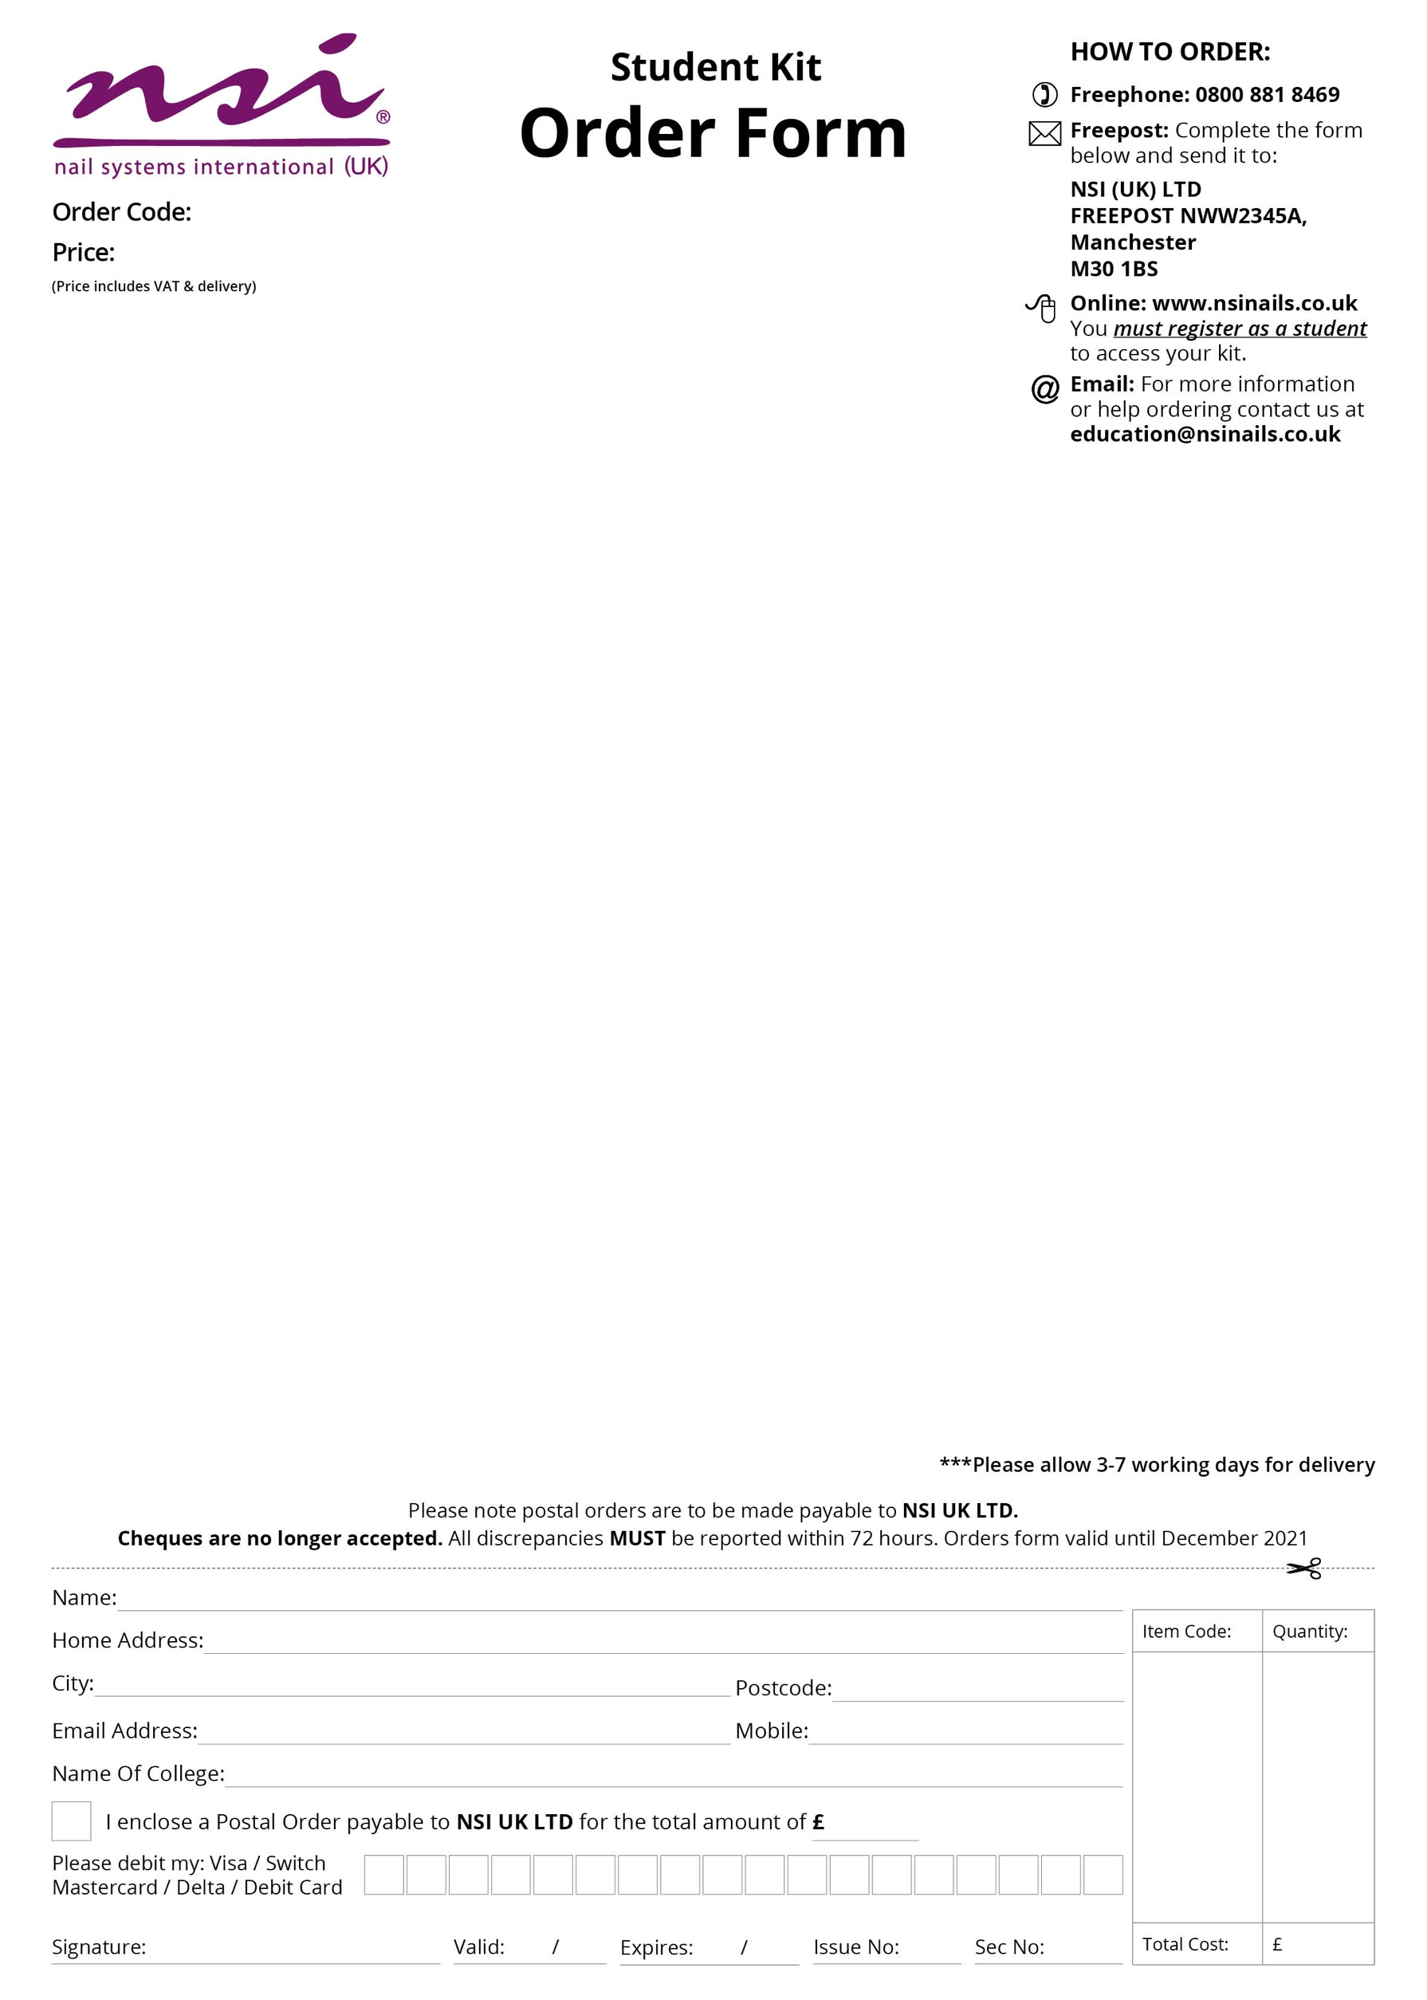­

* Sparkling Glitter Diamond Love 3gm
* Sparkling Glitter Grape Jelly 3gm
* Precious Stones - Diamond
* Large Dappen Dish
* Cuticle Pusher (Stainless Steel)
* Economy Tip Cutters
* Large Blue Vinyl Carrying Bag
* New NSI Catalogue

Level 3 Nail Kit

* Attraction Liquid and Powder Yummy Deal:

Attraction Nail Liquid 8floz

Attraction Radiant White Powder 40gm

Attraction Totally Clear Powder 40gm

Attraction Purely Pink Masque Powder 40gm

* Attraction Sheer Pink Powder 40gm
* Attraction Purely Pink Powder 40gm
* Simplicite Colour Powder Start Your Engines 7gm
* Simplicite Colour Powder Deep Secrets 7gm
* Simplicité Colour Powder Beer Garden 7gms
* Nail Pure Plus 8floz
* Balance LED/UV Builder Blush 9.5gm
* Balance LED/UV Builder Clear 9.5gm
* Balance UV Builder White 7gms
* Glaze N Go LED 15ml
* No 5 Blue Kolinsky Brush
* No 8 Purple Kolinsky Brush
* Dura Glue 7ml
* Essential Bond Acid Free Primer 15ml
* Dura Files Sample Pack:

Dura File 100/100 Grit x2

Dura File 150/150 Grit x2

Dura File 180/180 Grit x2

* Dura Tips Natural 150ct (1-10)
* Polyester Glitter Baby Pink Ice

Wigan & Leigh College

£162.00

WIG001